**Deploying Phenotype Toolkit in REDCap: Implementation Guide**

| Version number: | Version 1.0 |
| --- | --- |
| Prepared by: | Standard Case Report Forms & REDCap Working Group |
| Effective date: | 7 March 2025 |
| Last review date: | 5 December 2024 |
| Applicable to: | Anyone downloading and using the phenotype toolkits in REDCap for building a data collection project |
| Enquiries |  |

**Contents**

**1. Introduction 3**

1.1 Purpose 3

1.2 Definitions 3

1.3 Use of the Toolkits 3

1.4 What is REDCap? 4

**2. Phenotype Toolkits Repository 4**

2.1. Toolkit Deployment 4

**3. How to upload the downloaded toolkit file from ZivaHub/Github into REDCap 8**

**4. Designing a longitudinal project with Toolkit instruments 10**

**5. Combining multiple field specific toolkits 12**

5.1 Challenges associated working with one or combined toolkits 12

5.2 Combining toolkits 14

**6. Adapting Toolkit instruments for your study whilst maintaining standardisation 17**

6.1 Deleting an instrument 17

6.2 Deleting a field /s 18

**7. Getting help with REDCap Toolkit deployment 20**

## Introduction

In collaboration with the H3Africa Phenotype Harmonisation Working Group, we established common phenotype-specific data collection toolkits that can be implemented across the African continent (and beyond). These toolkits incorporate both existing and newly developed phenotype standards, to promote harmonised collection of phenotype data for genomic research.

The benefits of using these toolkits are multi-fold;

(1) The toolkits are all aligned with existing, global data collection standards,

(2) the toolkits are specifically adapted for biomedical phenotype data collection in Africa, and

(3) the toolkits are highly interoperable, with variables mapped to existing and maintained ontologies.

### 1.1 Purpose

The purpose of this document is to provide step-by-step instructions (including links to tutorial videos) on how to build a REDCap project using the phenotype toolkits.

### 1.2 Definitions

instrument - questionnaire / Case Report Form / data collection form

GitHub - a cloud-based platform where you can store, share, and work together with others to write code. Storing your code in a "repository" on GitHub allows you to: Showcase or share your work. Track and manage changes to your code over time.

phenotype - The observable characteristics or traits in an individual based on the expression of their genes. The phenotype is determined by the individual's genotype and possibly influenced by other factors, such as environmental factors or other genetic modifiers.

toolkit - collection of data collection instruments focused on a particular field of interest

ZivaHub - is an online, institutional data repository that serves as a publishing and access platform to research data and scholarly outputs. It is powered by [Figshare for Institutions](http://www.figshare.com/) and is available to all students and staff at UCT. Ziva is the Shona word for knowledge.

### 1.3 Use of the Toolkits

If you choose to make use of these toolkits and instruments, we welcome feedback and queries that can be directed here: <https://github.com/AfriGen-D/Phenotype_Collection_Toolkits> or <https://helpdesk.afrigen-d.org/helpdesk/>

We also ask that you please reference and cite our work in your publications in order to promote the benefits of using standardised data collection instruments using the following:

*In the methods section of publications:*

"The data collection toolkits (DOI) used were developed by H3ABioNet/H3Africa and were compiled using a variety of resources described in [https://GitHub.com/h3abionet/h3aphenstds](https://github.com/h3abionet/h3aphenstds) and, from 2024 onwards, <https://github.com/AfriGen-D/Phenotype_Collection_Toolkits>.”

*In the acknowledgements section:*

"We acknowledge the use of data collection toolkits (DOI) from H3ABioNet/H3Africa which can be found, including associated references, at [https://GitHub.com/h3abionet](https://github.com/h3abionet), funded by the H3Africa NIH grant U24HG006941."

*In the references section:*

Lyndon Zass, Katherine Johnston, Alia Benkahla, Melek Chaouch, Judit Kumuthini, Fouzia Radouani, Liberata Alexander Mwita, Nihad Alsayed, Taryn Allie, Dassen Sathan, Upendo Masamu, Milaine Sergine Seuneu Tchamga, Tsaone Tamuhla, Chaimae Samtal, Victoria Nembaware, Zoe Gill, Samah Ahmed, Yosr Hamdi, Faisal Fadlelmola, Nicki Tiffin, Nicola Mulder; “Developing Clinical Phenotype Data Collection Standards for Research in Africa”; <https://doi.org/10.1155/2023/6693323>

### 1.4 What is REDCap?

REDCap is a web-based application for building and managing surveys and databases, enabling secure data collection both online and offline. Developed at Vanderbilt University in the United States, Project REDCap (<https://www.project-redcap.org/>) is an open source data collection platform created and continually upgraded thanks to a small REDCap software and development team at Vanderbilt. REDCap is now used all over the world in many countries and institutions, free of charge for non-profit organisations and is an easy to use, efficient data collection system. REDCap was originally developed for the collection of clinical research data via online surveys but is used and applied in many different settings and data collection scenarios, though it is still primarily for clinical research data collection.

## 2. Phenotype Toolkits Repository

A list of the latest version of the H3Africa phenotype toolkits can be accessed on the H3ABioNet GitHub repository. The repository provides links to additional information about the development of the toolkits, domains of data collection and related publication/s. It is a publicly accessible repository which means anyone can have access to the content without any restrictions of passwords or usernames. The GitHub repository provides a space to log issues that users may have with regards to the toolkits and additional links for contacts and support are provided at the end of this documentation.

### 2.1. Toolkit Deployment

To access the Phenotype Toolkits GitHub repository go to the URL [https://GitHub.com/h3abionet/h3aphenstds/tree/main](https://github.com/h3abionet/h3aphenstds/tree/main) and the repository will open showing a list of all the toolkits ready for downloads.

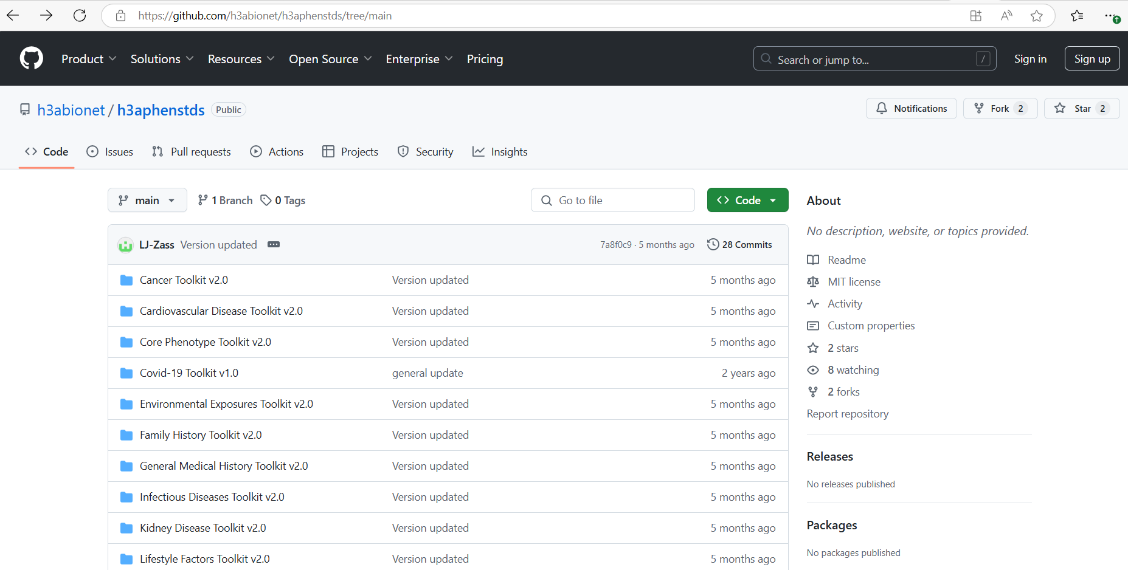

The user can then select and download one or more toolkits (from the list highlighted in red) that they wish to use to build a REDCap research data collection project.

These toolkits incorporate both existing and newly developed phenotype standards, to promote harmonised collection of phenotype data for genomic research. The benefits of using these toolkits are multi-fold; (1) The toolkits are all aligned with existing, global data collection standards, (2) the toolkits are specifically adapted for biomedical phenotype data collection in Africa, and (3) the toolkits are highly interoperable, with variables mapped to existing and maintained ontologies.

To successfully deploy the toolkit one must first download the toolkit from GitHub or ZivaHub and then upload it to a REDCap project as an XML file. The example below is a demonstration of how to download a Core Phenotype toolkit from the GitHub repository. To download from the GitHub repository follow the steps below:

**2.2.1 Example - How to download Core Phenotype Toolkit v2.0 from GitHub**



**Open this link** [GitHub - h3abionet/h3aphenstds](https://github.com/h3abionet/h3aphenstds/tree/main)

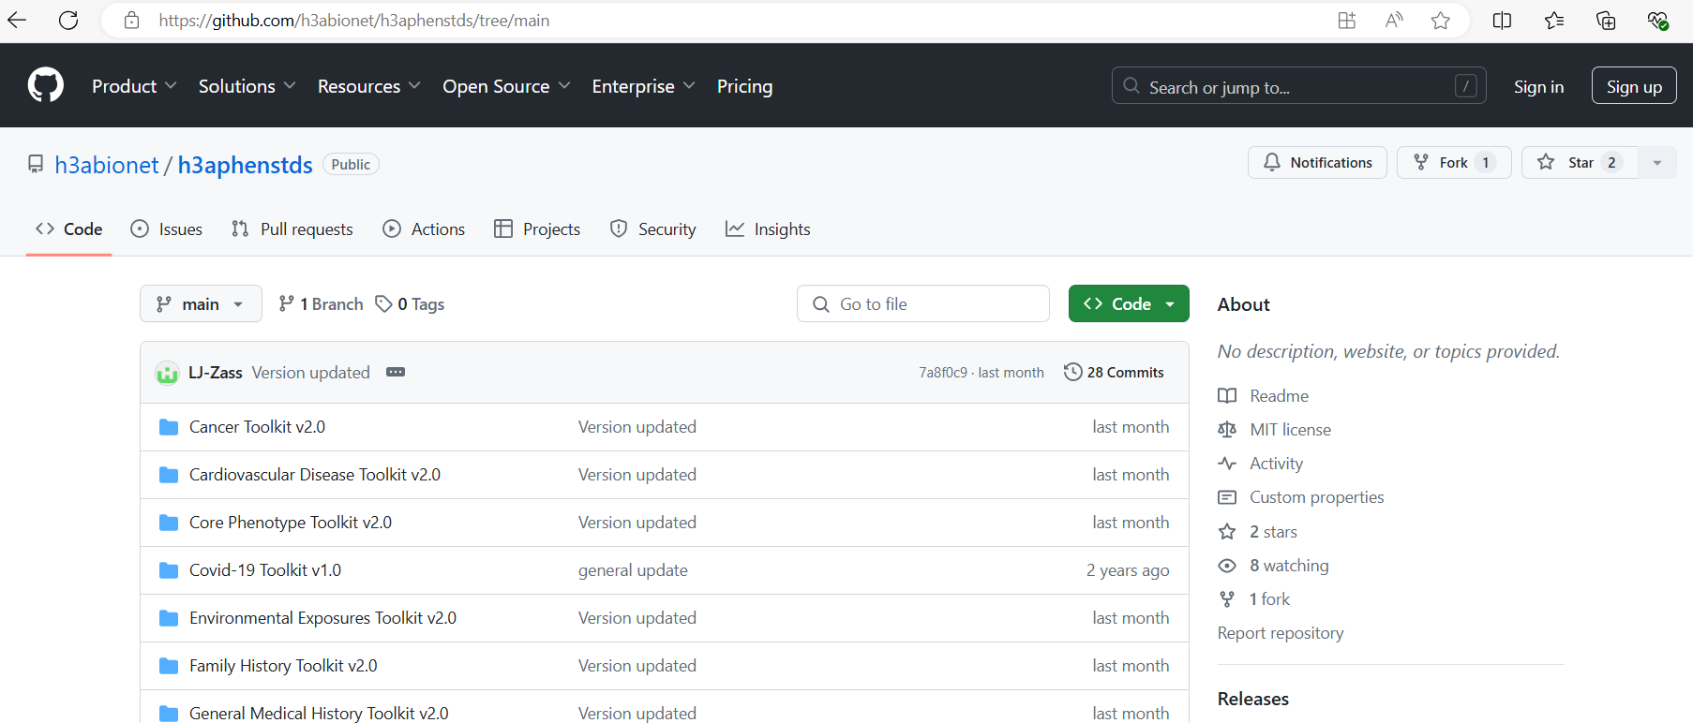

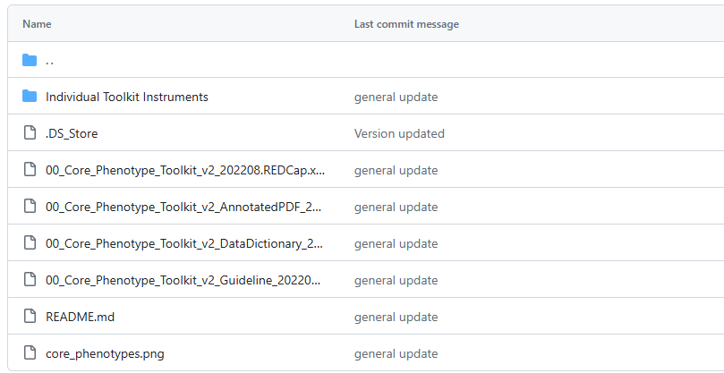

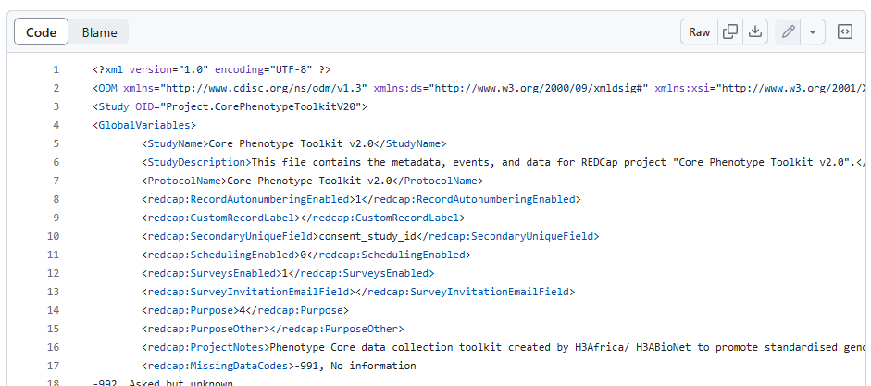

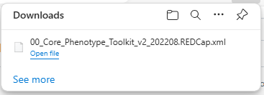

**2.2.2 Example - How to download Core Phenotype Toolkit v2.0 from ZivaHub**

The example below is a demonstration of how to download a Core Phenotype toolkit from the ZivaHub repository. To download from the GitHub repository follow the steps below:



**Open this link :** [H3Africa PHWG Data Collection Toolkit - Core Phenotypes v2.0 (uct.ac.za)](https://zivahub.uct.ac.za/articles/standard/H3Africa_PHWG_Data_Collection_Toolkit_-_Core_Phenotypes_v2_0/21152731) `

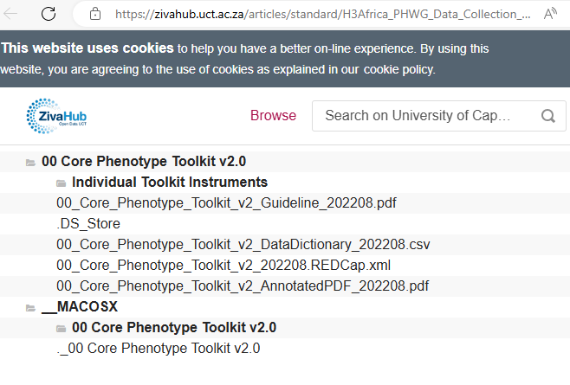 

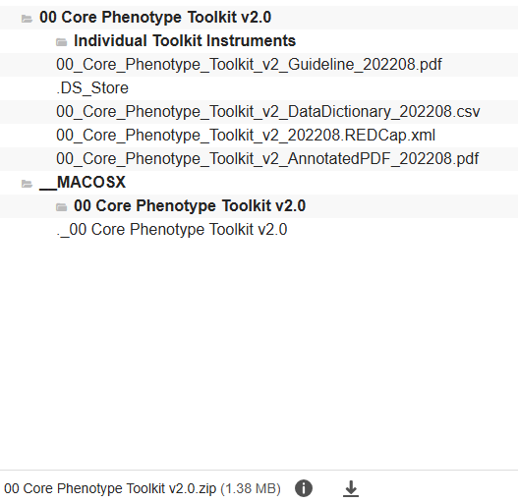

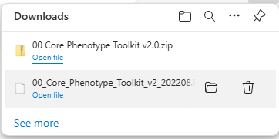

## 3. How to upload the downloaded toolkit file from ZivaHub/Github into REDCap

The downloaded XML files must be uploaded as a new project in REDCap. Assuming you have successfully logged in REDCap and you can see the home page below, click New Project button.

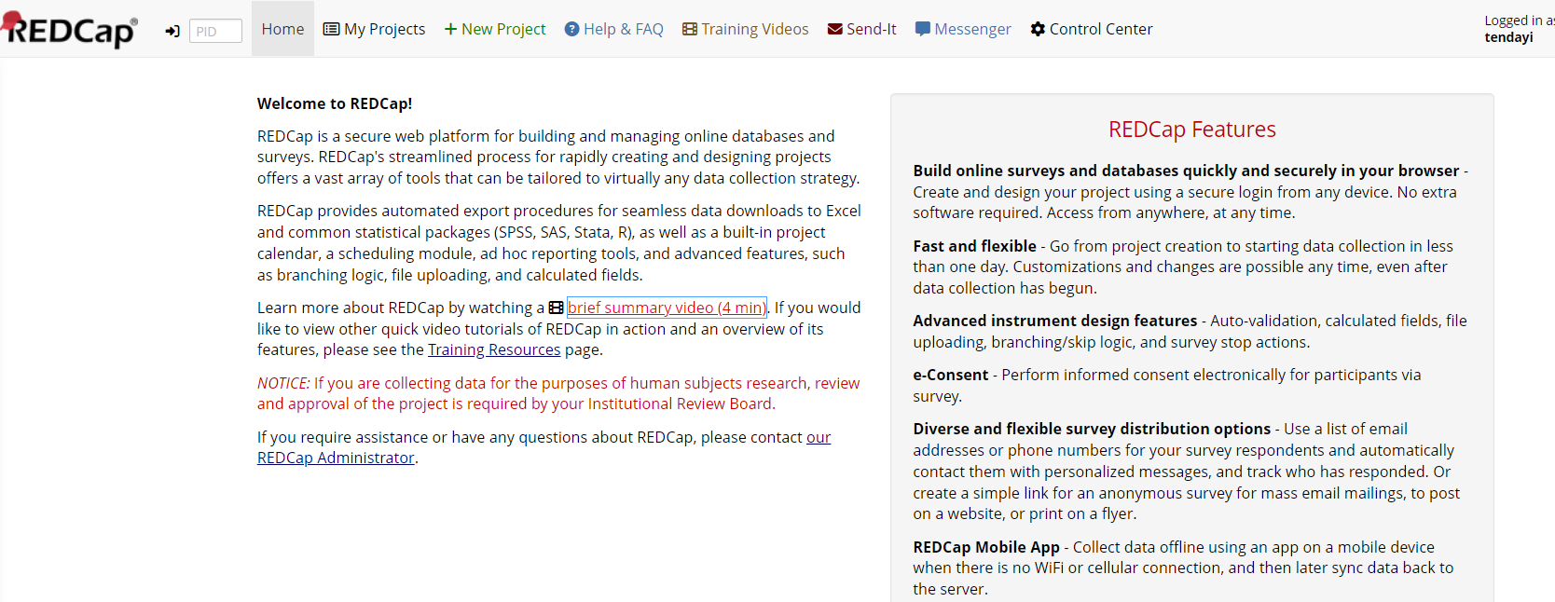

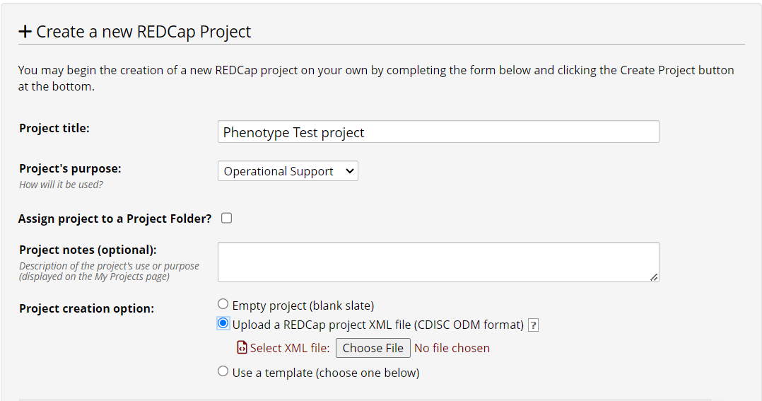

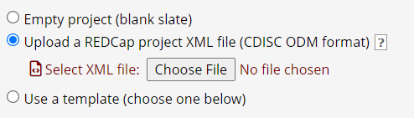

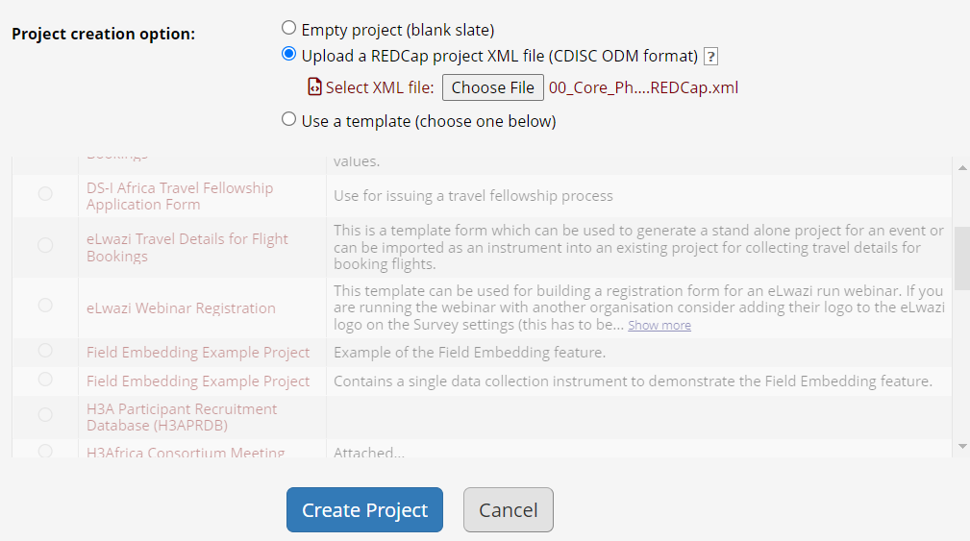

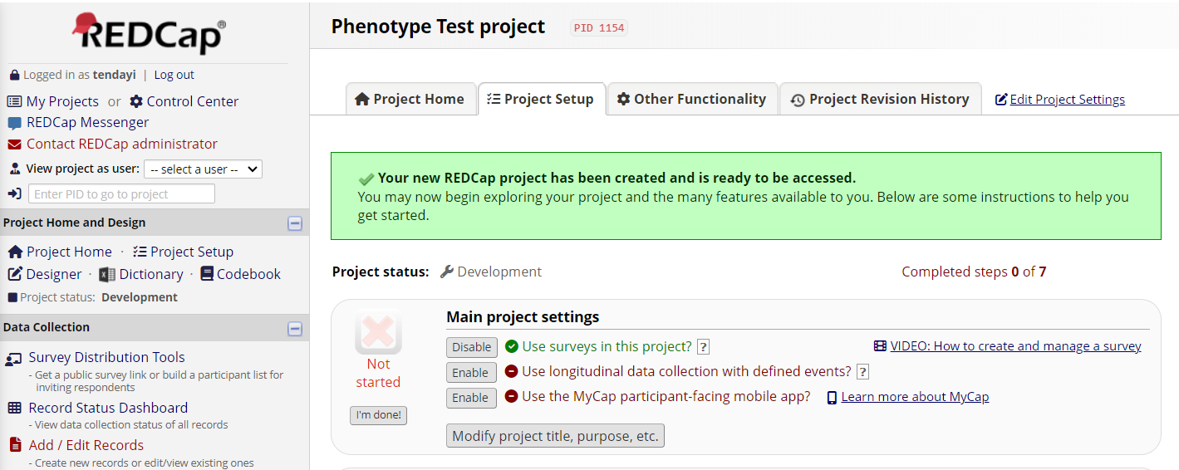

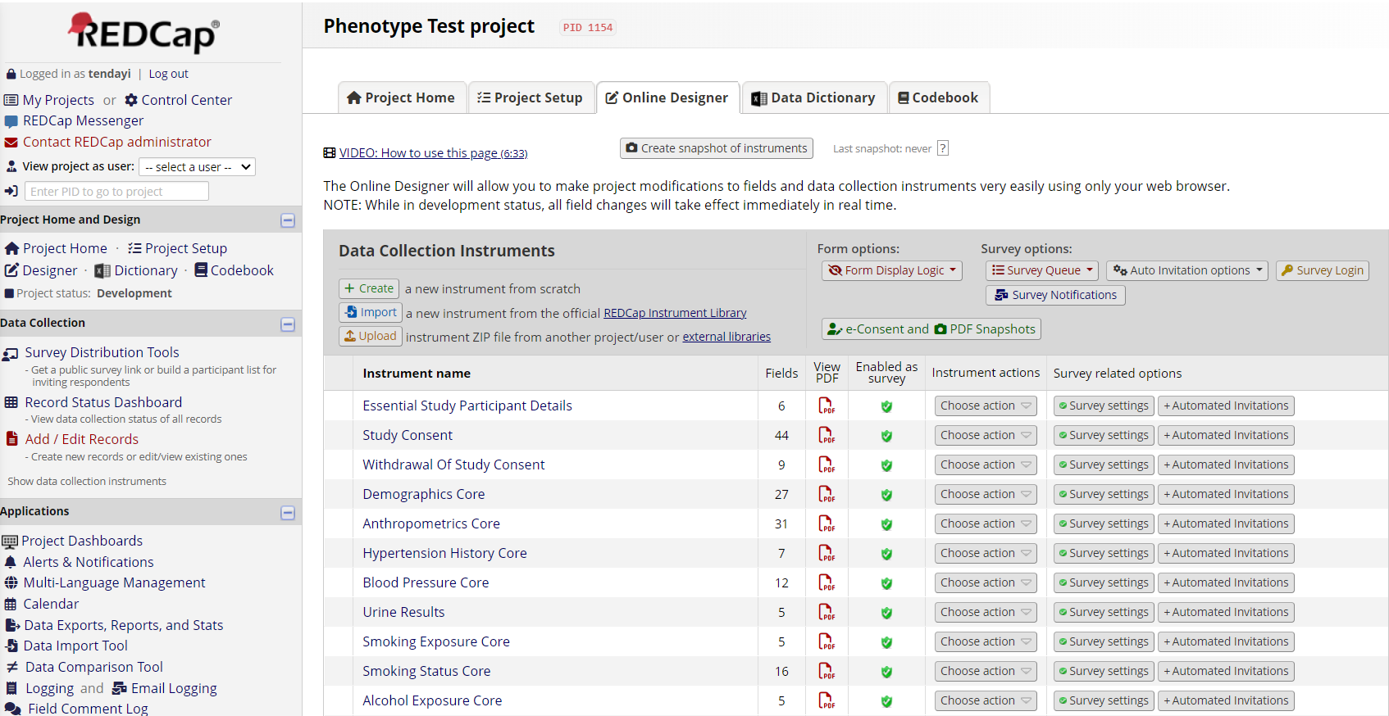

## 4. Designing a longitudinal project with Toolkit instruments

Once your REDCap project is created, you will be configuring your project and creating instruments to use during data collection. REDCap is very customizable and can be used for various use cases, we will only touch on the basics of designing and configuring a REDCap project here. Longitudinal projects allow for the collection of data over time with the ability to track changes and progress. Longitudinal instruments eliminate the need to recreate multiple of the same forms, where instead the form is created once and assigned to multiple time points within a project. Some useful situations for longitudinal projects include:

* Long term studies
* Clinical trials
* Recruitment and enrollment combinations
* Multi-site studies
* Repeating surveys (medications, lab results, adverse events forms)

The following example is a step-by-step for longitudinal projects:

Navigate to your project, and select the “Project Setup” tab on the home page.

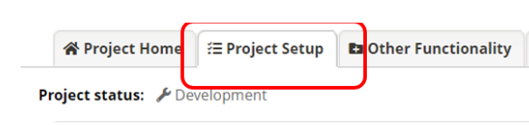

The second step is to click the “Enable” button under the “Main project settings”. The Enable button is next to “Use longitudinal data collection with defined events”

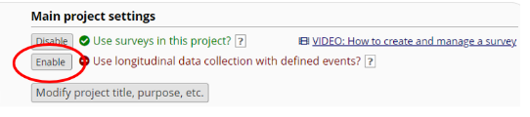

The third step is to define Events / Arms for the project. On the “Project Setup” click “Define My Events”

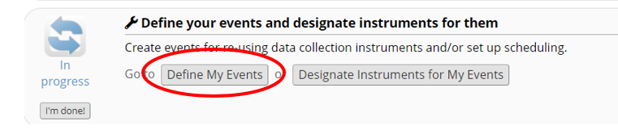

Type the name of the event in the text box, then click “Add New Event” Repeat this step for each event as needed

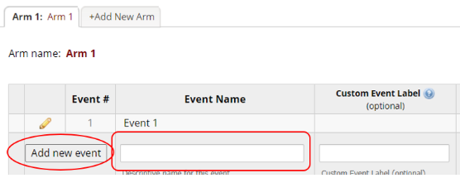

The fourth step is to link instruments to events. On the “Project Setup” click Designate Instruments for My Events” button and begin editing.

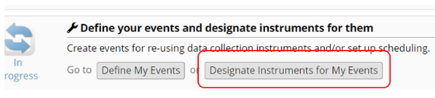

Select “Begin Editing” from the screenshot below.

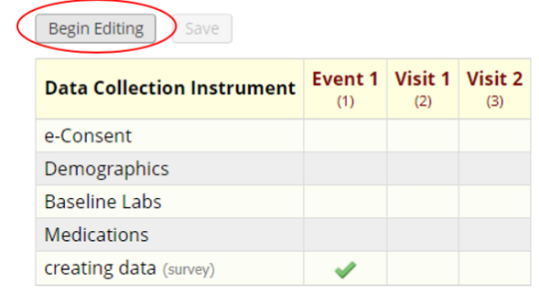

Check the data collection instrument that should be assigned to each specific event. After selecting, click “Save”.

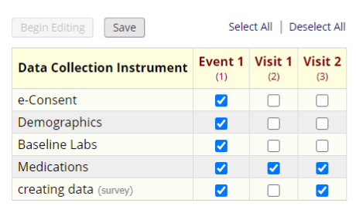

## 5. Combining multiple field specific toolkits

This section explains how users can combine data collection instruments from multiple field specific toolkits by selecting and downloading the individual instruments from GitHub and importing them into a REDCap project.

### 5.1 Challenges associated working with one or combined toolkits

* The user might download a toolkit with some fields not necessary for the study.
* The user might download a toolkit with some individual toolkits not necessary for the study.
* The user might want to collect data which is not included in the toolkit
* The user might fail to import a toolkit in REDCap

**Example:** With an established Core Phenotypes project in REDCap, if you are a researcher looking at tuberculosis and environmental factors, you would take individual instruments from the Environmental Impact Toolkit and Infectious Diseases Toolkit.

The following example will you a step by step example on how to explore a toolkit and how to download single instruments and upload to an established REDCap study

** Open this link** [GitHub - h3abionet/h3aphenstds](https://github.com/h3abionet/h3aphenstds/tree/main)

 

Take the environmental toolkit (it includes Core Phenotypes)

 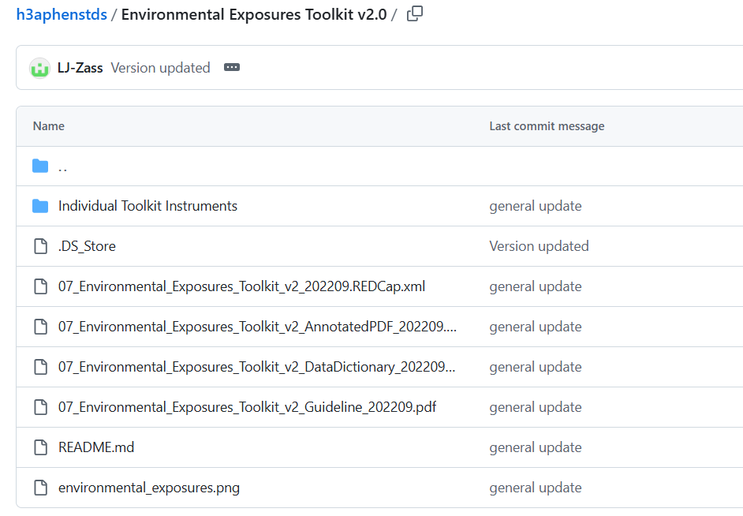

 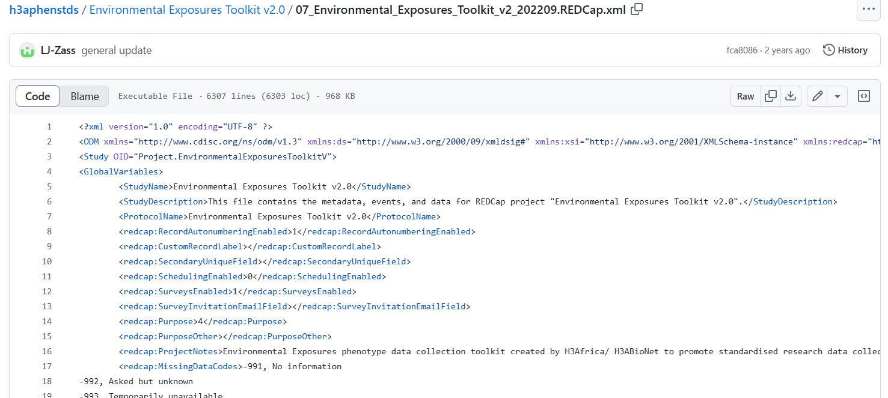

Assuming the user is combining two toolkits, repeat steps 1 - 4 to download the second toolkit.

### 5.2 Combining toolkits

The following example shows how to combine two individual instruments and upload to a REDCap project. For this example we use the downloaded Environmental Exposures Toolkit and the Tuberculosis Sign and Symptoms zip files.

 

 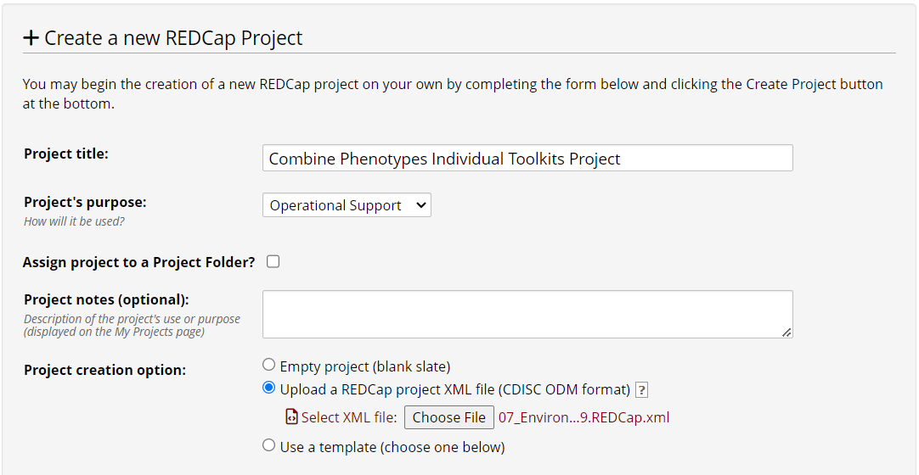

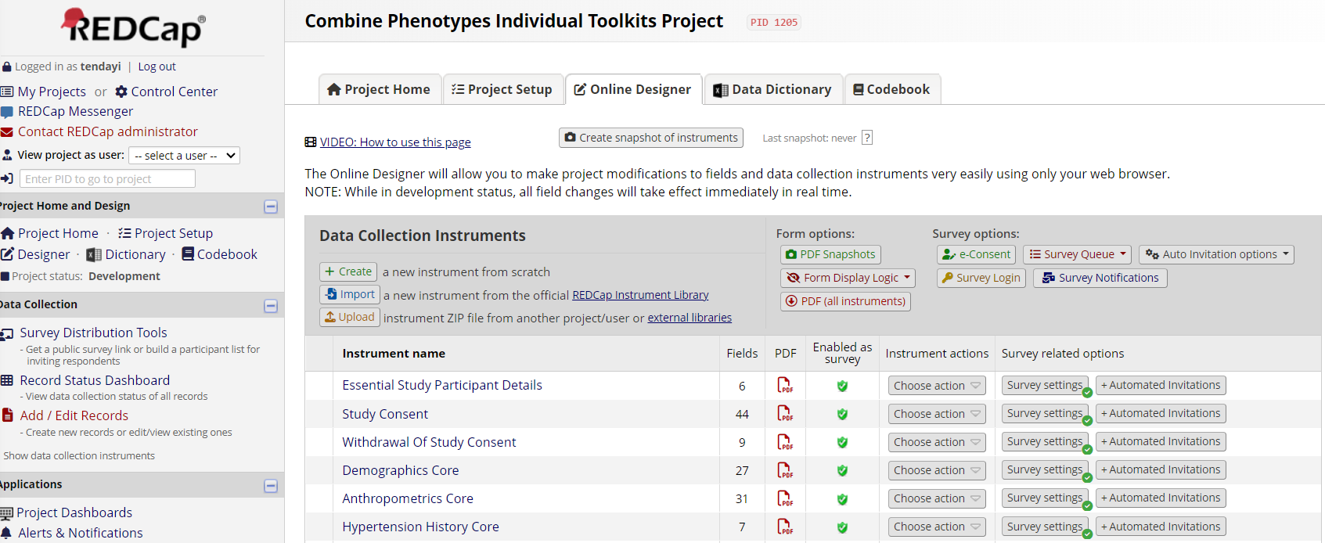

After successfully creating the project and the instruments are listed under the instrument name list, the user needs to upload the second downloaded tuberculosis instrument zip file.

 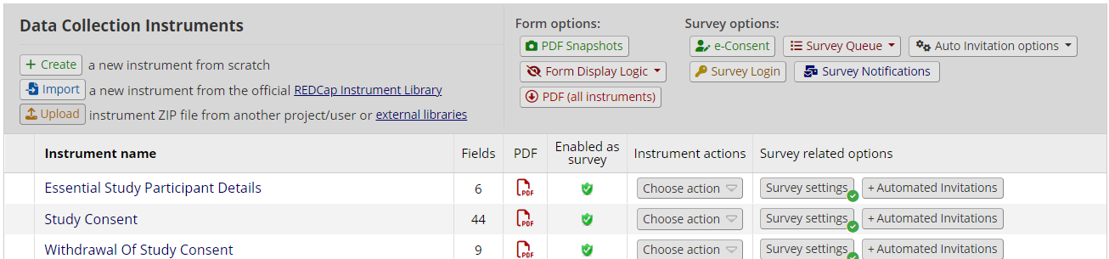

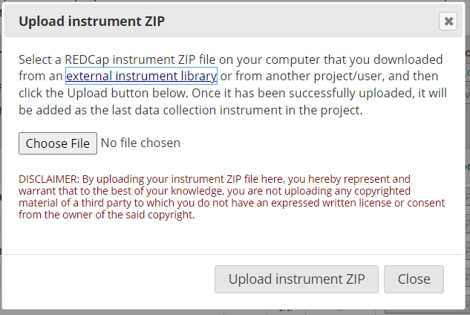

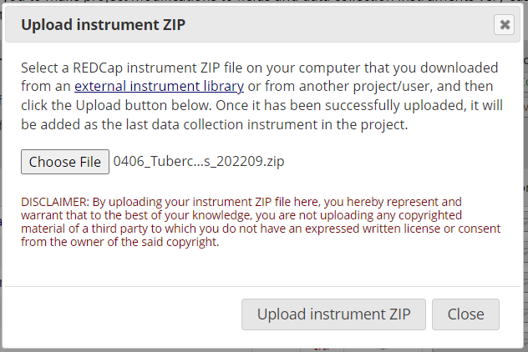

A pop-up window will open showing that the ZIP file was successfully uploaded.

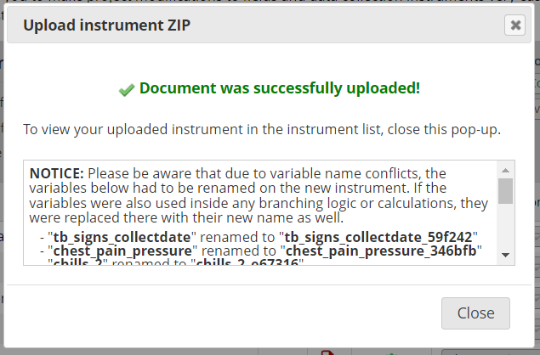

 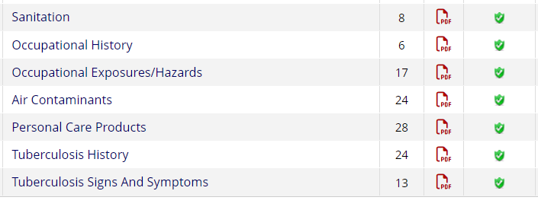

## 6. Adapting Toolkit instruments for your study whilst maintaining standardisation

This section demonstrates how to modify instruments, add new fields or questions and what to be careful of to not impact the standard in REDCap. This following is a step-by-step example on how to delete an entire instrument from your project.

### 6.1 Deleting an instrument

The user can delete the entire instrument from a project if they do not want the information to be included in their study. It is important to remember that this action will delete all the data capturing fields in that instrument. To delete the entire instrument from the instruments list, the user follow the steps below:

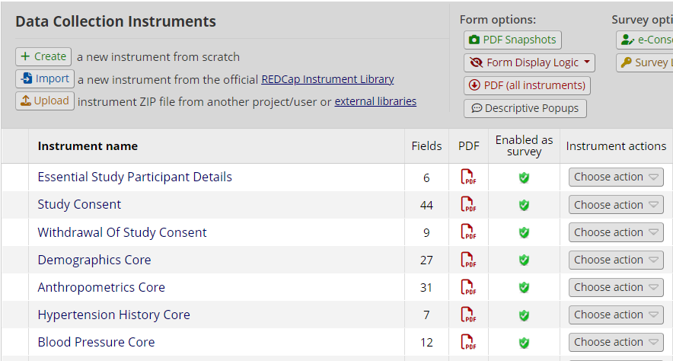

A pop-up window will appear prompting the user to Rename, Copy, Delete or Download Instrument ZIP. The user can choose any of the options available, but this example is for deleting an instrument.

 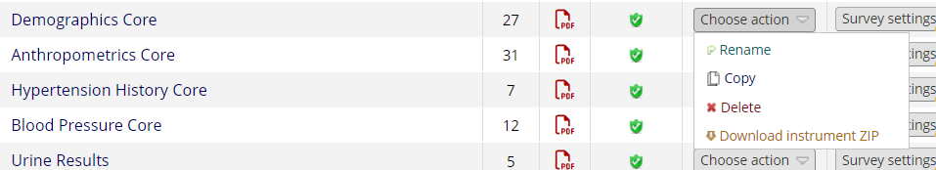

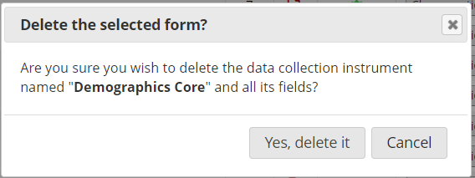

 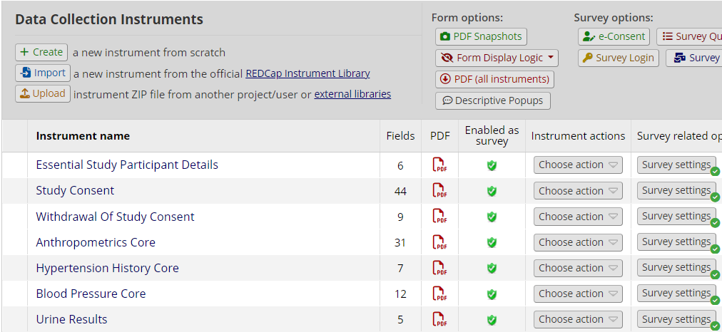

### 6.2 Deleting a field /s

The user may decide to delete certain fields on an instrument depending on what fields they need to use in a study. The following is a stp-by-step guide on how to delete fields in REDCap. This example shows how to delete a field under demographics core instrument.

** **

The instrument will open showing all the fields within that instrument. For this example, we are deleting the “ native language field”.

 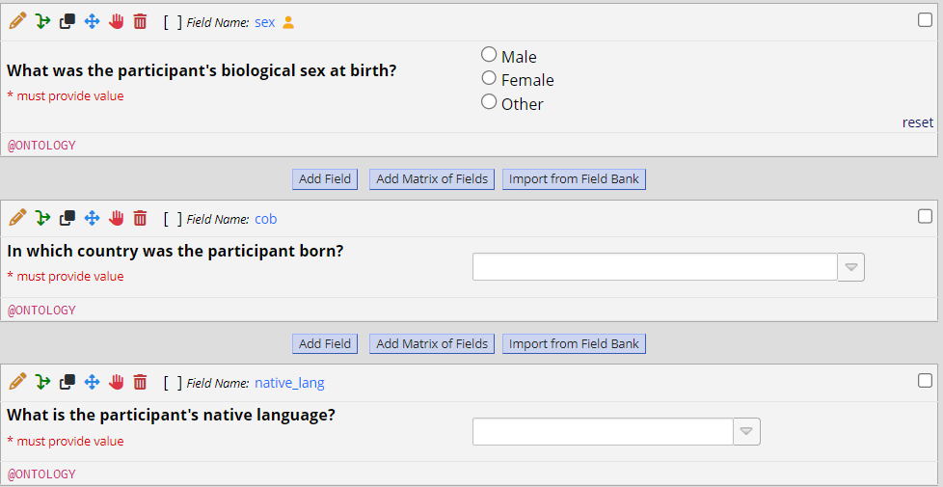

A pop-up window will appear prompting the user to confirm the deletion. Click the “delete” to confirm the action.

 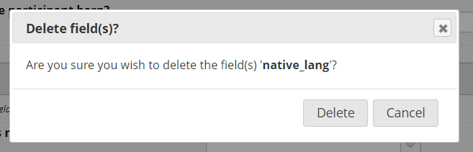

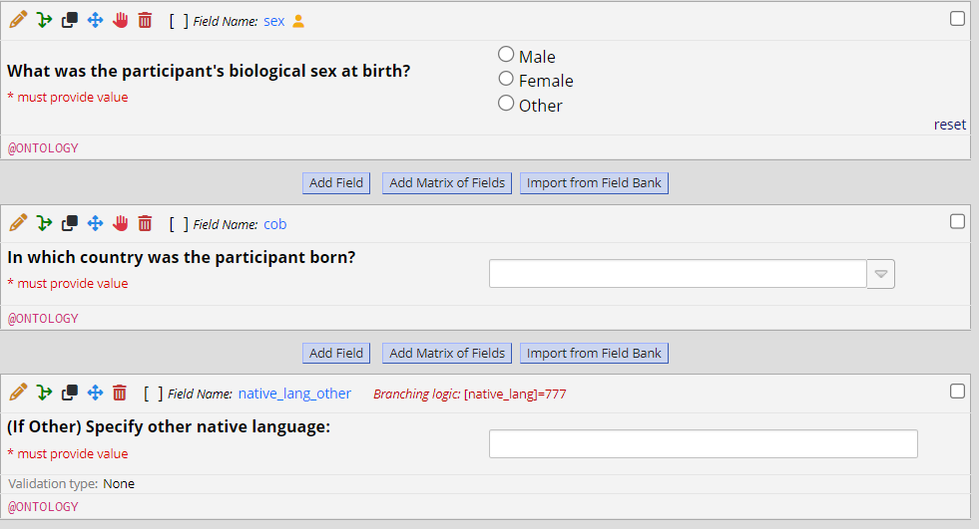

## 7. Getting help with REDCap Toolkit deployment

Getting help on how to deploy the toolkit, always refer to the implementation guide using this link [GitHub - h3abionet/h3aphenstds](https://github.com/h3abionet/h3aphenstds/tree/main). You may also get in touch with the AfriGen-D using the following email address